Comparative Evaluation of Transformer Models for AI-Generated Text Detection in English and French
Amine Es-saouiqui ^{1 ,} *, Maroua Alami Harrak ¹, Hajar El Yaziri ¹
and Mohamed Cherradi ^{1 ,†} .
¹ : Department of Mathematics and Computer Science , National School of Applied Science, Abdelmalik Essaadi University. Al Hoceima, Morocco.
* Correspondence : amine.essaouiqui@etu.uae.ac.ma
† Supervisor : email d prof.
Abstract :
As large language models rapidly evolve, telling AI-generated text apart from human writing has become a major challenge, especially across different languages. This paper introduces a multilingual framework designed to detect AI content in both English and French.
By leveraging transformer-based models, our approach captures the deep semantic and stylistic nuances that separate human authors from machines. To ensure the system doesn't unfairly favor one category over the other, we fine-tuned our decision thresholds on a validation set, perfectly balancing precision and recall. Finally, our best-performing model went to distilled multilingual BERT variant trained with parameter-efficient fine-tuning, proved highly adaptable across languages and exceptionally reliable.
Our findings underscore the power of multilingual transformers and highlight how crucial threshold optimization is for dependable, balanced AI detection.
keywords : AI-generated text detection, multilingual natural language processing, English–French text classification, human vs machine classification, transformer-based models, threshold optimization, parameter-efficient fine-tuning

The code associated with this study is available on GitHub: https://github.com/ae-saouiqui/ai-text-detection
Co-authors :

- Introduction
The rapid advancement of large language models has significantly enabled them to generate a highly coherent text. While these developments have opened new opportunities across various domains such as education, content creation, and automated assistance, they have also introduced critical challenges.
One of the most important challenges is the increasing difficulty of distinguishing between human-written and AI-generated text, as modern generative models produce outputs that closely resemble natural human language.
This issue becomes even more complex in multilingual environments, where variations in syntax, vocabulary, and linguistic structure can influence model behavior and detection performance. In particular, distinguishing AI-generated content across languages such as English and French requires approaches that are robust to linguistic diversity. As a result, AI-generated text detection in multilingual settings has become an active and important research area.
This has motivated a growing body of work addressing the detection of machine-generated content, often framed within shared tasks and benchmarks that include both monolingual and multilingual settings (Wang et al., 2024).
These studies highlight the complexity of the problem, where models must generalize across diverse domains, languages, and generative sources.
However, existing approaches have shown limitations, especially under domain shift and adversarial conditions such as paraphrasing, where performance often degrades significantly (Antoun et al., 2023). Similarly, studies focusing on specific languages, such as French, demonstrate that while detection models can perform well in controlled settings, their robustness outside the training distribution remains a major challenge.
Overall, these works underline the need for more robust and generalizable approaches to AI-generated text detection in multilingual and real-world scenarios.
In this work, we focus on a multilingual approach for AI-generated text detection, targeting both English and French texts.
The objective is to design a robust classification framework capable of identifying whether a given text is human-written or generated by an artificial intelligence system. To achieve this, we leverage transformer-based representations that are well-suited for capturing deep semantic and contextual information across different languages.
Moreover, since French text-based models perform poorly on AI text detection tasks when evaluated on data outside the training distribution,typically limited to a single domain,we attempted to improve robustness by incorporating additional data sources such as essays, code generation, and other diverse text types.
A key aspect of this study is the emphasis on balanced and reliable detection performance across both classes. Since both false positives and false negatives are equally important in practical scenarios, special attention is given to decision-making at inference time. In particular, the best-performing configuration among different variants is selected using an optimized thresholding strategy on the validation set. This threshold is tuned to maximize both precision and recall for the two classes, ensuring a balanced trade-off between detection sensitivity and reliability.
The final evaluation of generalization capability is carried out by comparing the selected models on the test set.
The remainder of this paper is organized as follows:
Section 2 presents the related work and reviews prior studies in the field;
Section 3 describes the dataset and its preparation;
Section 4 details the proposed methodology, including the training procedure, models used, threshold optimization strategy, and experimental setup and results
Section 5 concludes the paper.
- Related Work :
This section presents previous studies related to AI-generated text detection, focusing on approaches that are relevant to our work.
A survey by Xiang et al. reviews recent progress in AI-generated text detection and proposes a taxonomy relevant to our work. They categorize methods into passive and active approaches, depending on whether they rely on intrinsic textual features or embedded signals. Passive methods include surface linguistic and language model-based techniques, while active methods involve watermarking and semantic retrieval strategies. Their study also highlights key limitations of current detectors, particularly their vulnerability to adversarial attacks such as paraphrasing, which significantly reduces performance and generalization. Overall, their findings emphasize the need for more robust and domain-general detection methods, which aligns with the goals of our multilingual approach.
Adilazuarda et al. conduct a comprehensive comparison of traditional shallow classifiers, language model fine-tuning, and multilingual model fine-tuning for machine-generated text detection and model attribution. Using FastText-based features and multiple pre-trained transformers, they show that fine-tuned pre-trained language models substantially outperform shallow methods and that multilingual fine-tuning (mBERT, DistilBERT) helps mitigate language-specific biases and maintain strong performance across languages, highlighting the importance of multilingual training strategies for robust detection [2].
Antoun et al. investigate ChatGPT detection in multilingual and cross-domain settings. They train classifiers using translated datasets and evaluate them in both monolingual and multilingual scenarios. Their study further examines generalization on out-of-domain data and evaluates robustness against adversarial attacks such as character substitutions and misspellings. Their results reveal important limitations in existing detectors, particularly in real-world and adversarial conditions, emphasizing the need for more robust and generalizable approaches [3].
Wang et al. introduce the GenAI Content Detection Task, a shared benchmark designed to evaluate machine-generated text detection in both monolingual and multilingual settings. The task includes diverse domains, multiple state-of-the-art generative models, and a wide range of languages, making it a challenging benchmark for evaluating generalization. Their work provides a comprehensive evaluation framework that reflects real-world conditions and highlights the difficulty of robust detection across languages, domains, and modern generative systems [4].
- Datasets

Dataset collection :
Several benchmark datasets have been proposed for machine-generated text detection. Early efforts such as HC3 (Guo et al., 2023) include both English and Chinese texts generated by large language models. Other datasets, including MGTBench, ArguGPT, and DeepfakeTextDetect, focus on texts generated by different large language models across various domains. More comprehensive benchmarks such as M4 and M4GT-Bench (Wang et al., 2024) extend this work by covering multiple domains, languages, and generation sources. [Figure 1]
In our study we focus only on the English portion of these benchmarks [4].
The French dataset is constructed from two main sources. The first is the HC3-OOD dataset provided by Antoun et al., while the second is a French instruction dataset composed of multiple translated and native French corpora.
The HC3-OOD dataset contains human and ChatGPT-generated conversations adapted to out-of-domain settings, providing challenging examples for detection. The French instruction dataset includes a mixture of translated instruction-following datasets and native French sources such as WikiHow FR and other conversational corpora. This dataset was originally designed for training and evaluating instruction-based language models, but it can also be used for distinguishing between human-written and AI-generated text [5].
Fortunately, both provided a test set drawn from different sources than the training set, serving as a valid benchmark for model generalization [6].
Table 1 summarizes the number of samples in the English and French datasets aimed to used for training in this work.

Table 1 : Summary of Training Dataset Samples
Dataset | English | French
Count | 610767 | 464885
Total | 1075652

Table 2 : Summary of Test Dataset samples
Dataset | English | French
Count | 70000 | 15000
Total | 85000

Dataset preparation :
The collected data underwent several preprocessing steps to improve consistency and data quality.
First, hyperlinks, markdown syntax, and other formatting artifacts were removed from the text. Standard text preprocessing was then applied prior to training.
For model training, a subset of 500,000 samples was selected. The training set includes 200,000 English samples and 200,000 French samples, each maintaining a balanced distribution between human-written and AI-generated text.
To improve robustness against noisy and real-world inputs, an additional 100,000 augmented samples were introduced containing OCR and keyboard-induced perturbations [7].
The augmented subset was designed with asymmetric class distributions depending on the noise type.
OCR-based noise contains 80% AI-generated and 20% human-written samples, while keyboard-error augmentation follows the inverse distribution, with 80% human-written and 20% AI-generated samples.
In addition to the training data, we construct a separate validation set of 100,000 samples which follows an imbalanced distribution consisting of 80% human-written text and 20% AI-generated text in order to better reflect realistic scenarios where human-authored content is more prevalent.
Table 3: Distribution of samples used for training and validation set.
Split | Human | AI | Total
en-train | 100K | 100K | 200K
fr-train | 100K | 100K | 200K
ocr-augmentation (fr/en) | 10K | 40K | 50K
key-augmentation (fr/en) | 40K | 10K | 50K
en-val | 40K | 10K | 50K
fr-val | 40K | 10K | 50K
Table 3 presents the distribution of human-written and AI-generated samples across the training, augmentation, and validation datasets used in this study.
- Methodology

Model Architecture
The proposed approach is based on transformer encoder models adapted for binary sequence classification. Each model consists of a pre-trained transformer encoder followed by a task-specific classification head that outputs the probability of a text being human-written or AI-generated [Figure 1].
To evaluate the effectiveness of different pre-trained representations, multiple transformer-based backbones are fine-tuned within the same classification framework. Despite differences in their pre-training strategies and architectures, all models share the same overall design and are adapted to the same downstream task.
The framework is designed to support multilingual inputs, enabling consistent processing of both English and French texts within a unified classification setup.

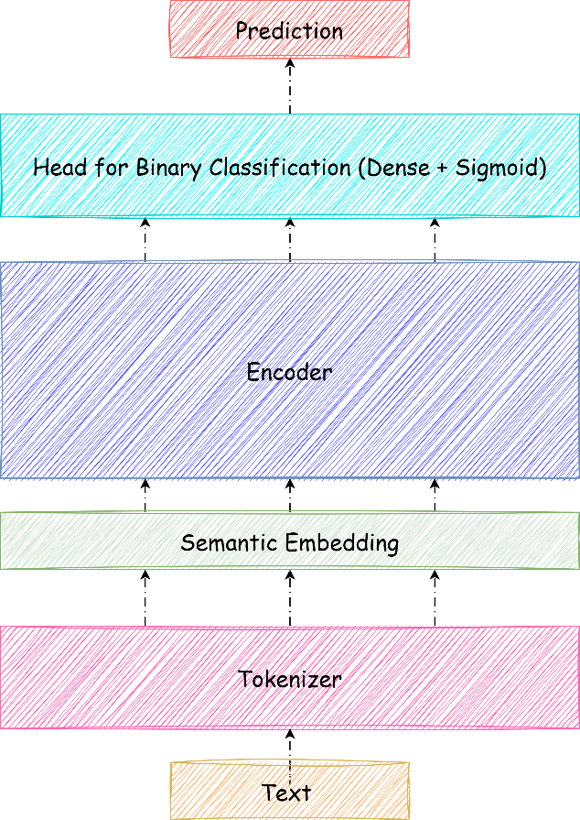
Figure 1 : Model Architecture

- Fine-tuning Strategy :
To evaluate different transformer architectures and fine-tuning strategies, we conduct experiments using three configurations: mELECTRA [8], mDistilBERT [9], and mDistilBERT with Low-Rank Adaptation (LoRA) [10].
All models are adapted for binary sequence classification using a shared classification framework consisting of a transformer encoder followed by a classification head [Figure 1].
The first two models (mELECTRA and mDistilBERT) are fine-tuned using standard full-parameter training.
In contrast, the third configuration applies LoRA[11] to mDistilBERT, where only a small number of additional low-rank parameters are trained while the original backbone weights remain frozen. This allows for a comparison between full fine-tuning and parameter-efficient fine-tuning under identical training conditions.
This setup enables a fair evaluation of both architectural differences and the impact of LoRA on model performance for AI-generated text detection.
- Hyperparameter configuration :
All models are fine-tuned using the Hugging Face Trainer API, which provides a unified training framework for transformer-based sequence classification.
This ensures consistent implementation across all experiments, including data loading, optimization, evaluation, and checkpoint management. The main hyperparameters used for each model configuration are summarized in Table 4 .

Table 4 : Hyperparameters used for finetuning
Parameter | mELECTRA | mBERT-Distil | mDistilBERT + LoRA
Epochs | 3 | 3 | 2
Batch Size | 4 | 4 | 16
Learning Rate | $2 ×{10}^{-5}$ | $$2 ×{10}^{-5}$$ | $$2 ×{10}^{-4}$$
Weight Decay | 0.01 | 0.01 | 0.01
Max Sequence Length | dynamic < 512 | dynamic <512 | 512
Optimizer | AdamW | AdamW | AdamW
Warmup Steps |  | — | 500
Scheduler | — | — | Cosine
Mixed Precision | FP16 | FP16 | FP16

For the mDistilBERT model, we apply Low-Rank Adaptation (LoRA) to enable parameter-efficient fine-tuning.
In our setup, LoRA is applied specifically to the query and value projection matrices of the self-attention mechanism. The configuration used is as follows:
Table 5 : LoRA configuration
Parameter | Value
Task Type | Sequence Classification
Rank (r) | 8
LoRA Alpha | 16
Dropout | 0.1
Bias | None
Target Modules | q_lin, v_lin

- Threshold optimization :
After Training, we perform threshold optimization on the validation set to improve classification reliability. The optimal threshold is selected by evaluating different cutoff values and choosing the one that maximizes and compromises both precision and recall across the two classes. This approach ensures a balanced trade-off between false positives and false negatives, which is particularly important in AI-generated text detection where both error types are equally critical.

The validation results of the ELECTRA model before threshold optimization [Table 6]reveal a clear imbalance in prediction behavior. While the model achieves high recall for the AI-generated class (0.95), its precision remains relatively low (0.57), indicating a tendency to over-predict AI-generated text. In contrast, the human class exhibits high precision (0.98) but lower recall (0.82), suggesting that a portion of human-written samples are incorrectly classified as AI-generated. These results highlight the limitation of using a default decision threshold of 0.5, motivating the need for threshold optimization to achieve a more balanced trade-off between precision and recall across both classes.
Table 6 : classification report of mElectra on validation set with a threshold od 0.5
 | precision | recall | f1-score
Human | 0.98 | 0.82 | 0.9
AI | 0.57 | 0.95 | 0.71
Accuracy | 0.85

The decision threshold is selected based on validation performance with a focus on improving detection quality for the AI-generated class.
Specifically, we choose the threshold that ensures a minimum performance level (approximately 80%) for both precision and recall of the AI class, as this class represents the main source of classification errors in the default setting. This constraint helps reduce misclassification of AI-generated text while maintaining a balanced overall performance which has been shown in the [Figure 2].
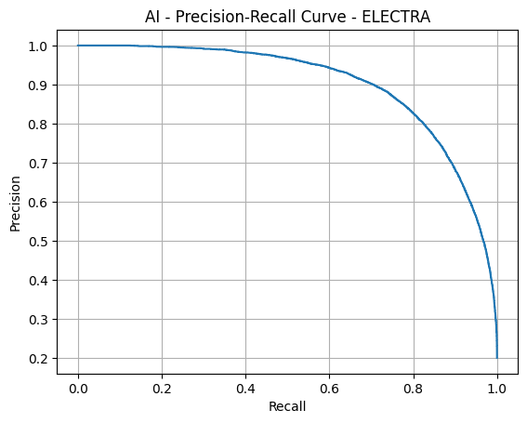
Figure 2 : AI Precision - Recall curve for Electra

Table 7 : classification report of mElectra on validation set with optimal threshold
 | precision | recall | f1-score
Human | 0.95 | 0.96 | 0.95
AI | 0.83 | 0.80 | 0.81
Accuracy | 0.93

The same threshold optimization strategy is applied to all remaining models, where the decision threshold is selected based on validation performance and guided by the class exhibiting the highest misclassification rate under the default setting, ensuring a balanced trade-off be
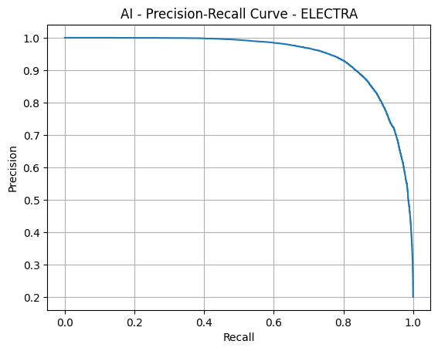
tween precision and recall.
Figure 3 : AI Precision - Recall curve for mDistill-BERT

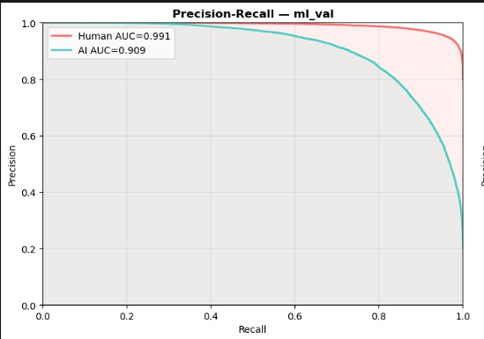
Figure 4 : AI-Human Precision - Recall curve for mDistill-BERT + LoRA

Table 8 : evaluation scores on validation set after score optimization
Model | Accuracy | Precision (AI) | Recall (AI) | F1 (AI) | Precision (Human) | Recall (Human) | F1 (Human)
mELECTRA | 0.93 | 0.83 | 0.80 | 0.81 | 0.95 | 0.96 | 0.95
mBERT-Distil | 0.95 | 0.93 | 0.80 | 0.86 | 0.95 | 0.98 | 0.97
mDistilBERT + LoRA | 0.93 | 0.87 | 0.77 | 0.82 | 0.94 | 0.97 | 0.96

- Test evaluation :
To evaluate the generalization capability of the proposed models, we report the final performance on the held-out test set. The decision thresholds selected on the validation set are kept fixed during testing to ensure a fair evaluation.

Table 9 : Final test performance :
Model | Accuracy | Precision (AI) | Recall (AI) | F1 (AI) | Precision (Human) | Recall (Human) | F1 (Human)
mELECTRA | 0.78 | 0.77 | 0.85 | 0.81 | 0.80 | 0.69 | 0.74
mBERT-Distil | 0.95 | 0.93 | 0.80 | 0.86 | 0.95 | 0.98 | 0.97
mDistilBERT + LoRA | 0.93 | 0.87 | 0.77 | 0.82 | 0.94 | 0.97 | 0.96

